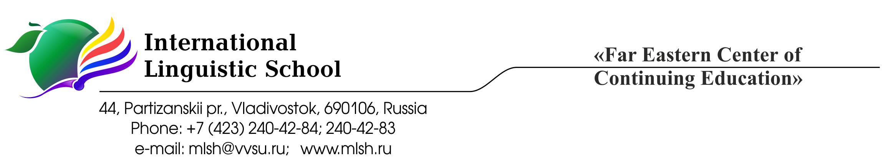
Inclusive Education Policy
The ILS mission is to create for our students an educational environment that encourages an intelligent, inquisitive approach to learning and a proactive approach to life; that teaches children how to help create a better, safer world; and that fosters love and respect for one’s own culture and history as well as the history and culture of other nations.
In keeping with our slogan “Education for Life”, ILS uses the International Baccalaureate programme as an instrument for students’ cognitive motivation and a means of encouraging them to be responsible, active people with a thirst for knowledge that will carry them successfully through life.
It is important for our graduates to be skilled decision makers and problem solvers, guided by proper personal values, critical, creative thinking, and effective action in a wide range of situations and in cooperation with others and with due care for people’s health and safety. (ILS Mission Statement)
How the School understand inclusion
International Linguistic School is committed to creating a learning environment where all students can feel valued for who they are and can fulfil their developmental potential. We understand and value the fact that all students have varied life experiences and a range of learning styles, strengths and challenges and we strive to offer the students opportunities to explore the possibilities open to them in our school, in our country and in the world, help them identify their long-term goals and guide them in their journey towards these goals.
The ILS community constantly work on identifying and removing barriers that may prevent school community members from realizing their full potential or threaten their sense of wellbeing and put every effort in meeting their academic, emotional and social needs.
ILS is a private educational institution that enrolls about 363 students ranging in age from 7 to 18 years old, with approximately 41 students in grades 10, 11, 12. Around 70% of students speak Russian as their first language and the remaining 30% are international students. There are very few students to whom English is the first or second language. Students come to ILS from private and state schools and have a wide range of ability levels. Some of the students stay in the school hotel during the school year and go home only for the weekend or on vacation.
In order to increase learning and participation students are placed in groups with similar educational backgrounds, the number of students in each group is kept to a minimum and cannot exceed 15 people. Students’ performance is constantly monitored and teachers are encouraged to share whatever concerns they have with the relevant member of the School administration. Native speaking personnel are employed in order to help international students adjust to the School environment and better understand their needs and worries.
Students in need of support are identified by the subject or language teachers or the class tutors. Parents may wish to indicate that the child has the need for support, whether documented or not, or the student may state that they need a certain form of support. Then a meeting is held in which the following parties may be involved depending on the nature of the support requested:
- the School principal
- the IB DP coordinator
- the School medical consultant
- the School psychologist
- the student’s parents
- the student’s class tutor and teachers (subject and language)
- the student themselves
Removing barriers
Physical
The School is situated in a nine-story building on several floors. The students usually use the stairs to access the places they need in the building. However, the students may ask the permission to use the elevator, which is normally used only by the staff. The permission is always given to those who have medical conditions which make it difficult for them to use the stairs.
The School also employs a medical consultant and has a well-equipped medical office, where the students who need regular medical manipulations can ask for help.
Social and emotional
The School teachers and staff realize that the educational standards and practices at ILS may differ considerably from the environment and the requirements of the educational institutions that the students attended before. This difference may give students some stress for the first few weeks of their life at ILS. For this reason at the beginning of the school year students attend a series of meeting with the School principal, the IB DP coordinator, the class tutor and subject teachers where the key points of the School policies are explained. The new students’ adjustment and performance are carefully monitored by the subject and language teachers and the class tutor for the first term of the year and, if necessary, changes can be made to the range of subjects studied by the student and the level of language training they receive.
The school psychologist is closely involved in all students’ emotional wellbeing at different levels. Firstly, the emotional climate in each grade community is studied and both teachers and students may be given personal recommendations on how the student can enhance their progress and make their communication with teachers and peers more effective. Secondly, the psychologist gives individual support to those students who experience stress for various reasons. Thirdly, the psychologist works with different age groups educating them about the emotional changes connected with their growth they may go through.
The school dormitory tutors help those students who stay in the dormitory during the school year. The School makes a point of employing staff who can speak the students’ native languages so that the students can better explain their needs and the language does not become a barrier to them.
Linguistic and educational
ILS teachers recognize and value the students’ different learning styles and accept the variety of the students’ strengths. They make every effort to differentiate instruction and use various supportive techniques and assessment methods to ensure that all students can learn and demonstrate their progress.
In order to successfully pursue the IB Diploma the students have to possess at least a higher-intermediate level of English and the School make every effort to help the students reach this level by the beginning of 11th grade. Students can gradually build this skill as they progress through Middle School and they can test their ability to study in English throughout their 10th grade. If necessary, additional English classes with native and non-native English teachers can be arranged. This experience helps them prepare for the challenges of the IB Diploma programme in grades 11 and 12.
The students also learn about the key features of the Diploma programme such as Theory of Knowledge, Creativity, Action, Service and Extended Essay while they are in the 10th grade and become prepared for the challenges each of these components may present. Assessment of the students’ progress in all subjects they take in the 10th grade is made according to the requirements of the Diploma programme so that the students become accustomed to the 1 -7 assessment scale and the grade descriptions. If students express additional educational needs, they may be provided with a relevant adviser (in Sciences, in the Arts, in sports) to guide them in their pursuit of the area of their interest throughout their DP experience.
The School community are committed to making every effort to remove all possible barriers to learning and create the caring and stimulating environment where students are encouraged to participate in their learning to the best of their ability.
Bibliography:
IB publications:
Diploma Programme: From principles into practice
Learning diversity and inclusion in IB programmes
Learning diversity in the International Baccalaureate programmes: Special educational needs within the International Baccalaureate programmes

