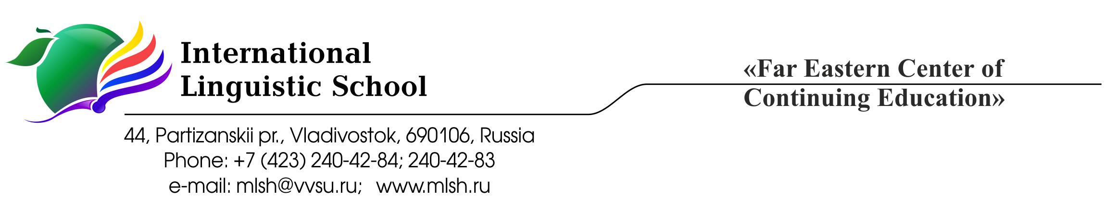
Academic Honesty
The ILS mission is to create for our students an educational environment that encourages an intelligent, inquisitive approach to learning and a proactive approach to life; that teaches children how to help create a better, safer world; and that fosters love and respect for one’s own culture and history as well as the history and culture of other nations.
In keeping with our slogan “Education for Life”, ILS uses the International Baccalaureate programme as an instrument for students’ cognitive motivation and a means of encouraging them to be responsible, active people with a thirst for knowledge that will carry them successfully through life.
It is important for our graduates to be skilled decision makers and problem solvers, guided by proper personal values, critical, creative thinking, and effective action in a wide range of situations and in cooperation with others and with due care for people’s health and safety. (ILS Mission Statement)
The School community believes that the best results can be achieved only in the environment where everybody’s contribution is rightfully acknowledged.
In line with the IB Learner Profile that states IB learners strive to be “principled - acting with integrity and honesty, with a strong sense of fairness and justice, and with respect for the dignity and rights of people everywhere, taking responsibility for the actions and their consequences” ILS community places high value on the work done honestly.
The IB publication Academic honesty in the IB educational context is the guide in defining the key principles concerning academic honesty policy in ILS. The purpose of this document is to help all members of the School community in understanding and applying these principles in their work.
What is academic misconduct?
Academic misconduct is a behaviour that results in, or may result in, the student or any other student gaining an unfair advantage (or a behaviour that disadvantages other students) in one or more assessment components.
Categories of “academic misconduct” in the IB:
Plagiarism is defined as the representation, intentionally or unwittingly, of the ideas, words or work of another person without proper, clear and explicit acknowledgment. The use of translated materials, unless indicated and acknowledged, is also considered plagiarism.
Collusion is defined as supporting academic misconduct by another student, for example allowing one’s work to be copied or submitted for assessment by another.
Misconduct during an IB examination includes taking unauthorized material into an examination room, disruptive behaviour and communicating with others during the examination.
Communication about the content of an examination 24 hours before or after the examination with others outside their school community is also considered a breach to IB regulations.
Duplication of work is defined as the presentation of the same work for different assessment components and/or Diploma Programme requirements.
Rules for students:
- Make clear which words, ideas, images and works are not your own (including maps, charts, musical compositions, movies, computer source codes and any other material).
- Give credit for copied, adapted and paraphrased material (including credit to your teacher, parent, friend, online source, etc.).
- Cite your sources so that readers can find them; if you cannot state the origin of the source it is probably better not to use it.
- When using text, make clear where the borrowed material starts and finishes.
- All sources cited in the text must also be listed in the bibliography (or reference list/ list of works cited) and all sources listed in the bibliography (or reference list/list of works cited) must be cited in the text. Follow the recommendations given in the IB publication Effective citing and referencing.
- Follow all exam and test rules.
- Ask your teacher for advice if you have any questions about academically honest behavior.
Examples of academic misconduct:
- Copying another student’s work or giving them your work to copy.
- Using materials or gadgets during a test or examination without the teacher’s permission.
- Having another person work on the assignment for you.
- Fabricating or altering research and experimental data.
- Working with someone else on the individual assignment.
- Disclosing or discussing the content of an examination paper with a person outside the immediate school community within 24 hours after the examination.
Consequences:
All instances of academically dishonest behavior are reported to the IB DP coordinator and the student’s parents are informed. The student receives zero as a grade for the work which is found to be academically dishonest. The descriptions of all the cases of academic misconduct are kept in the student’s school file and this information can be the reason to decline the request to write a recommendation letter for college admission. The School retains the right to mention the cases of academic misconduct if the college or university sends the application papers directly to the IB Coordinator.
The IB has no means of knowing whether an act of academic misconduct was deliberate or not. For this reason, a student’s intent cannot be taken into account if the IB investigates an alleged breach of the General regulations: Diploma Programme.
Be aware that a breach of IB regulations will have serious consequences.
The students sign the School “Academic Honesty Policy” to confirm that:
- They fully understand the principles explained in this document.
- They receive guidance on the skills of academic writing and acknowledging sources.
- They know what plagiarism, collusion and other types of academic misconduct are.
- They know the consequences of being found guilty of academic misconduct and are aware of the consequences.
Recommendations to teachers:
- Speak to the students about the principles of academic honesty outlined in this document. Explain what role academic honesty plays in constructing knowledge.
- Model the principles of academic honesty in your daily work (always cite the material that you use in class)
- Explain how the principles of academic honesty apply to each specific kind of assignment you are giving the students.
- Teach the students to appropriately cite the sources and list them in the bibliography using the information in the IB publication Effective citing and referencing.
- Do not neglect the cases of academic misconduct in daily work. Report all cases to the IB DP coordinator.
- Be ready to give the students advice on the ways to maintain academic honesty.
Recommendations to parents:
- Support the principles of academic honesty outlined in this document.
- Speak to your child about the importance of being honest in their academic work.
- Encourage your child to ask their teacher for advice concerning their work.
Bibliography:
IB publications:
Diploma Programme: From principles into practice (for use from August 2015)
Academic honesty in the IB educational context (published in August 2014, updated in November 2016)
Academic Honesty in the Diploma Programme

